**Assignment 3 – ISM 6218 Adv Databases**

**GROUP 2: Alphonse Aloia, Shruthi Priya Athikam, Krishna Sai Surya Teja Basetty, Malavika Parakkat Byju, Sahil Shah**

## **Idea 1: Investigating Selectivity**

Look up selectivity in your database textbook.  Essentially, the optimizer makes a decision regarding index use based on the fraction of results returned. Indexes are most useful when selecting a small fraction of the available records.  You can conduct a simple experiment to find out where the cutoff percentage lies by developing a simple single table query and gradually shrinking (or growing) the query range.

BEERS table in BEER DB

A number of queries were run to get a better insight on Selectivity using the beerdb.

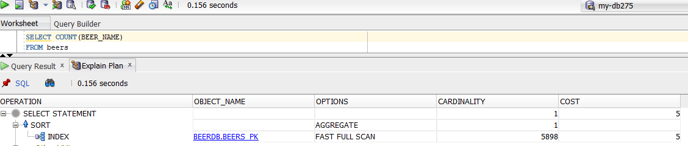

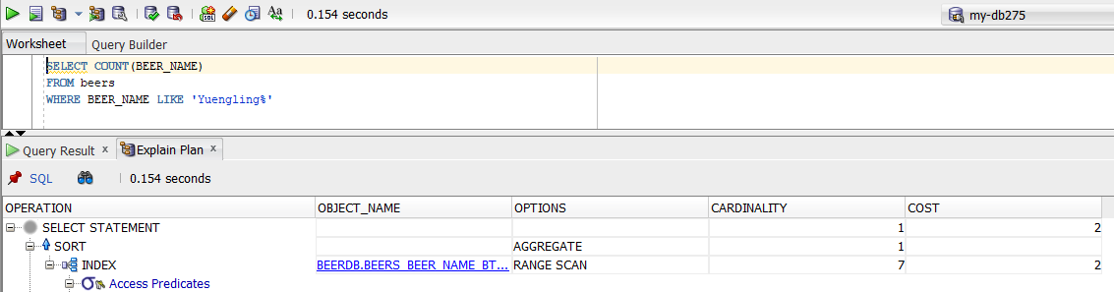

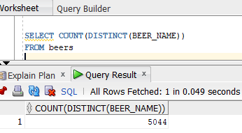

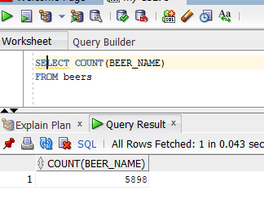

**Selectivity Ratio 0.855.**

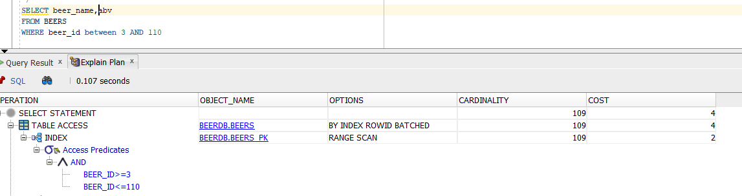

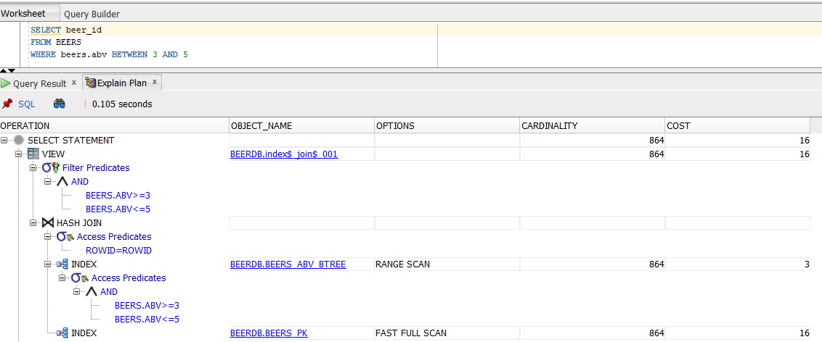

## **Idea 2: Start Simple and Show that Indexing Works**

Select *

FROM BEER_NAMES1

WHERE STYLE_ID = 15;

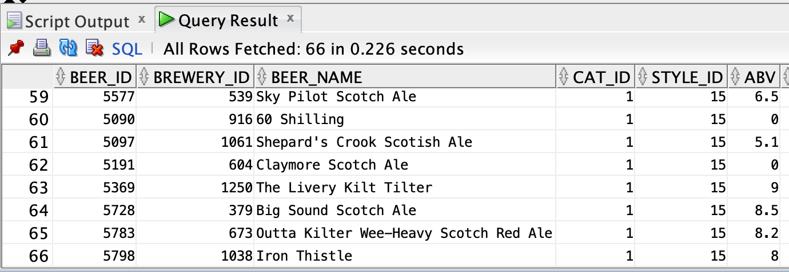

*Figure 1 - Performance Before Indexing: 0.226 seconds*

CREATE INDEX style_idx

ON BEER_NAMES1(STYLE_ID);

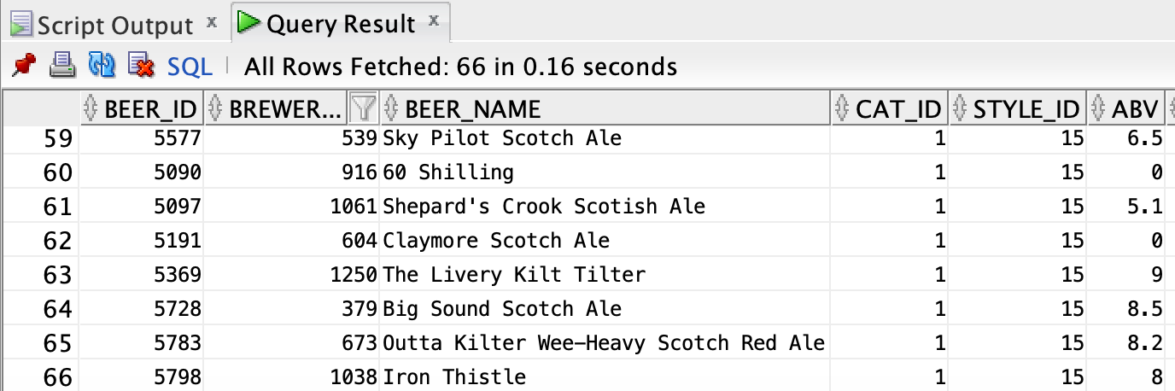

*Figure 2 - Performance After Indexing: 0.16 seconds*

**After indexing the fetching time reduced by 27.6%**

## **Idea 3: Primary Keys and Indexes**

1. Adding a unique constraint on Beer_ID

ALTER TABLE beer_names1  
ADD CONSTRAINT unqbber UNIQUE (BEER_ID);

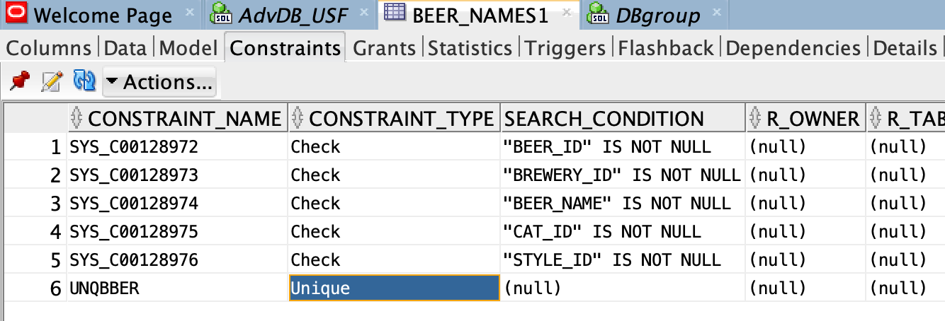

1. Inserting new row of data

INSERT INTO BEER_NAMES1 (BEER_ID, BREWERY_ID, BEER_NAME, CAT_ID, STYLE_ID) VALUES (6000, 539, 'TestLager1', 1, 15);

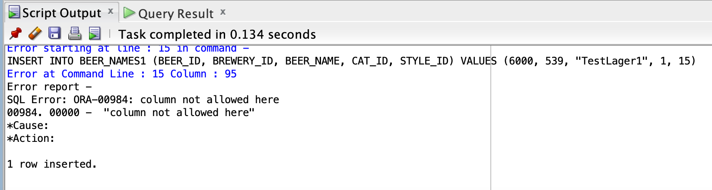

*Figure 3 - Unique Constraint on Beer_ID*

1. Performing same operation after adding Primary Key constraint on Beer_ID

ALTER TABLE beer_names1

DROP CONSTRAINT unqbber;

ALTER TABLE beer_names1

ADD CONSTRAINT PK_beer PRIMARY KEY (BEER_ID);

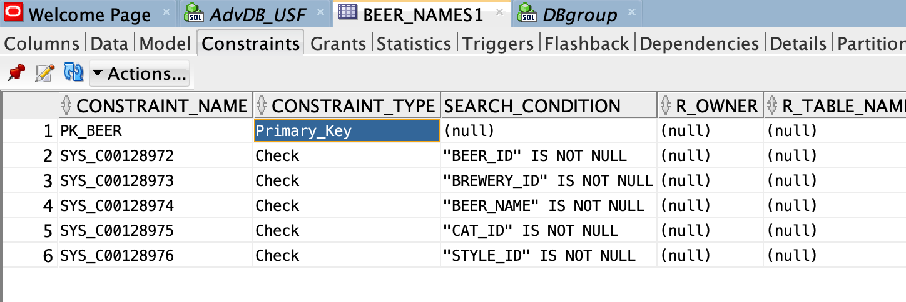

*Figure 4 - Adding Primary Key*

INSERT INTO BEER_NAMES1 (BEER_ID, BREWERY_ID, BEER_NAME, CAT_ID, STYLE_ID) VALUES (6001, 539, 'TestLager2', 1, 15);

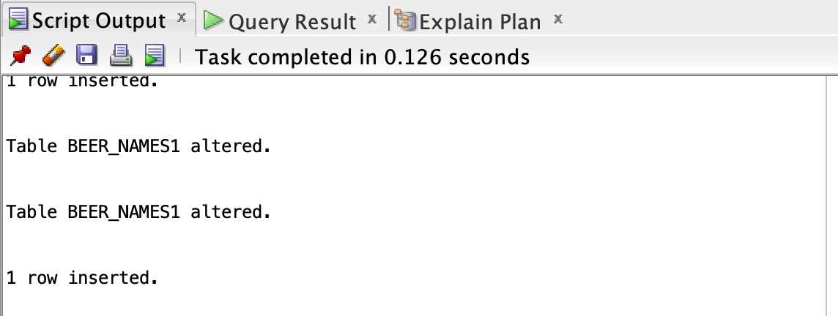

*Figure 5 - Output after adding PK Constraint*

Adding a primary key constraint reduced the time by 0.008s

## **Idea 4: Indexing for Different Query Types**

CREATE TABLE BEER_NAMES2 AS

SELECT * FROM BEERDB.beers;

**NON-INDEXED POINT, RANGE and SCAN QUERY results:**

1. **Point Query**

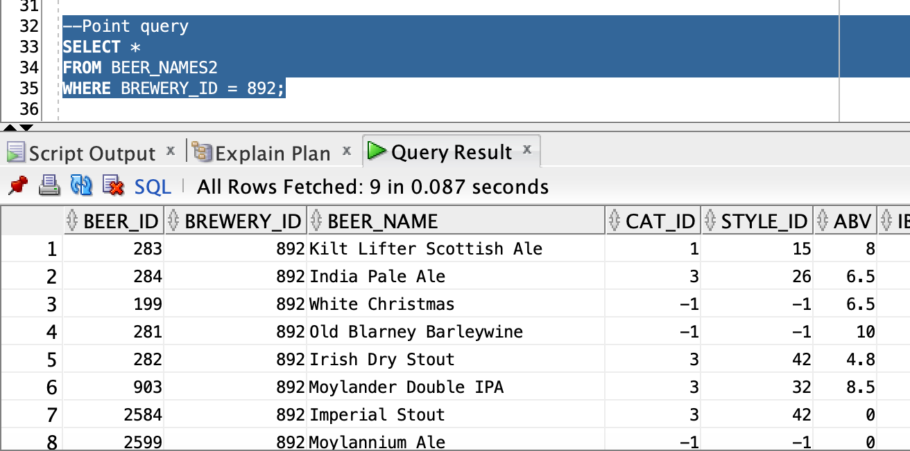

1. **Range Query**

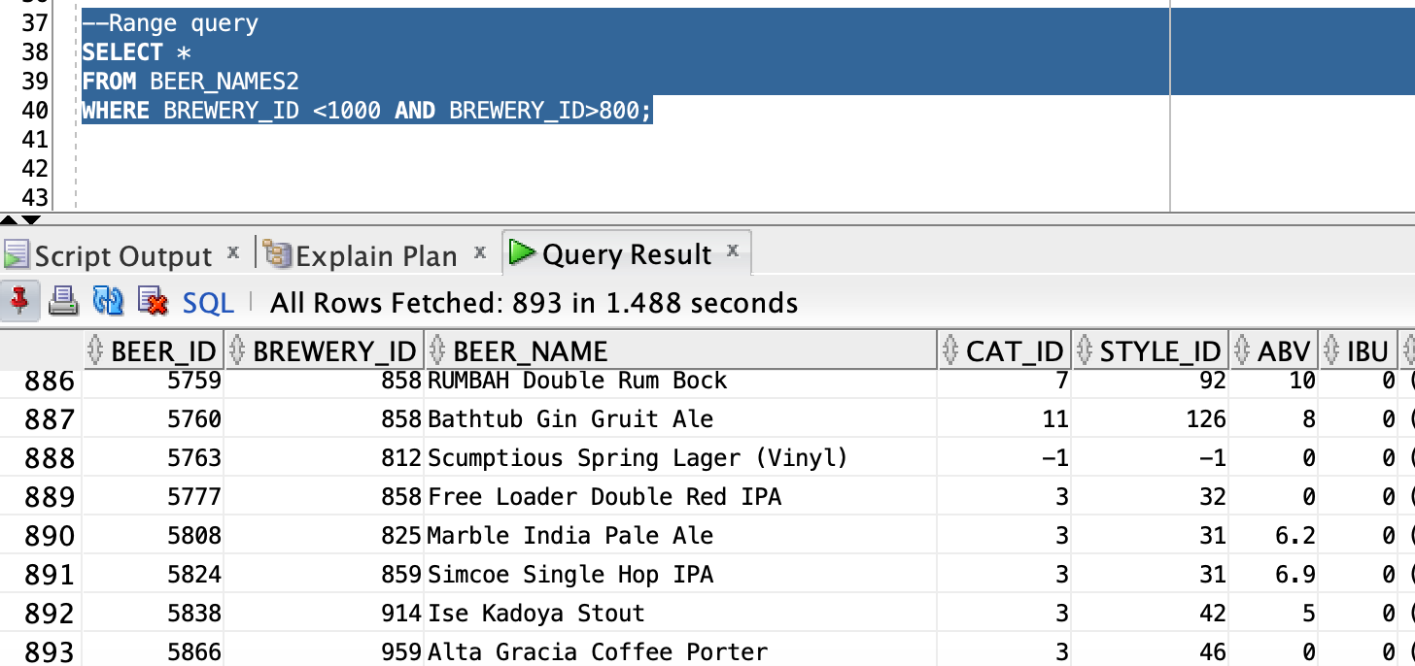

1. **Scan Query**

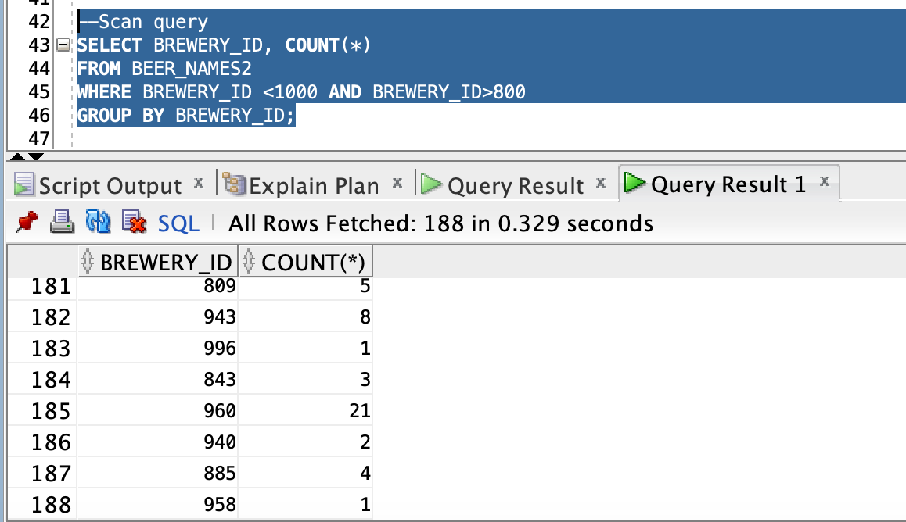

**Creating Index on Breweries_ID**

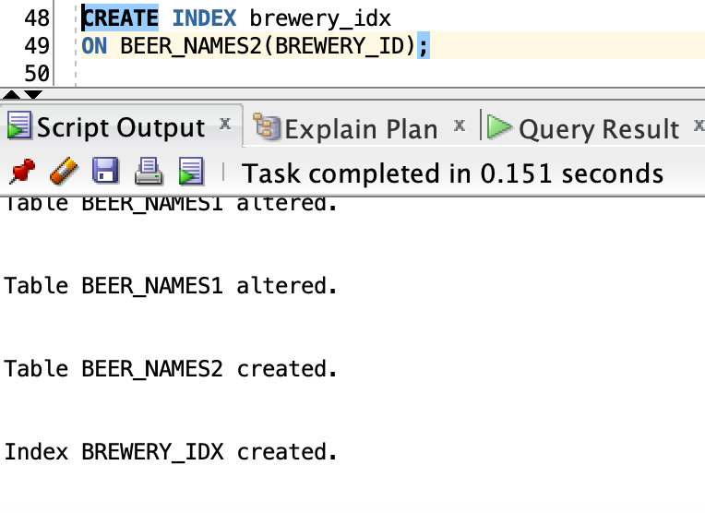

**INDEXED POINT, RANGE and SCAN QUERY RESULTS**

1. **Point Query**

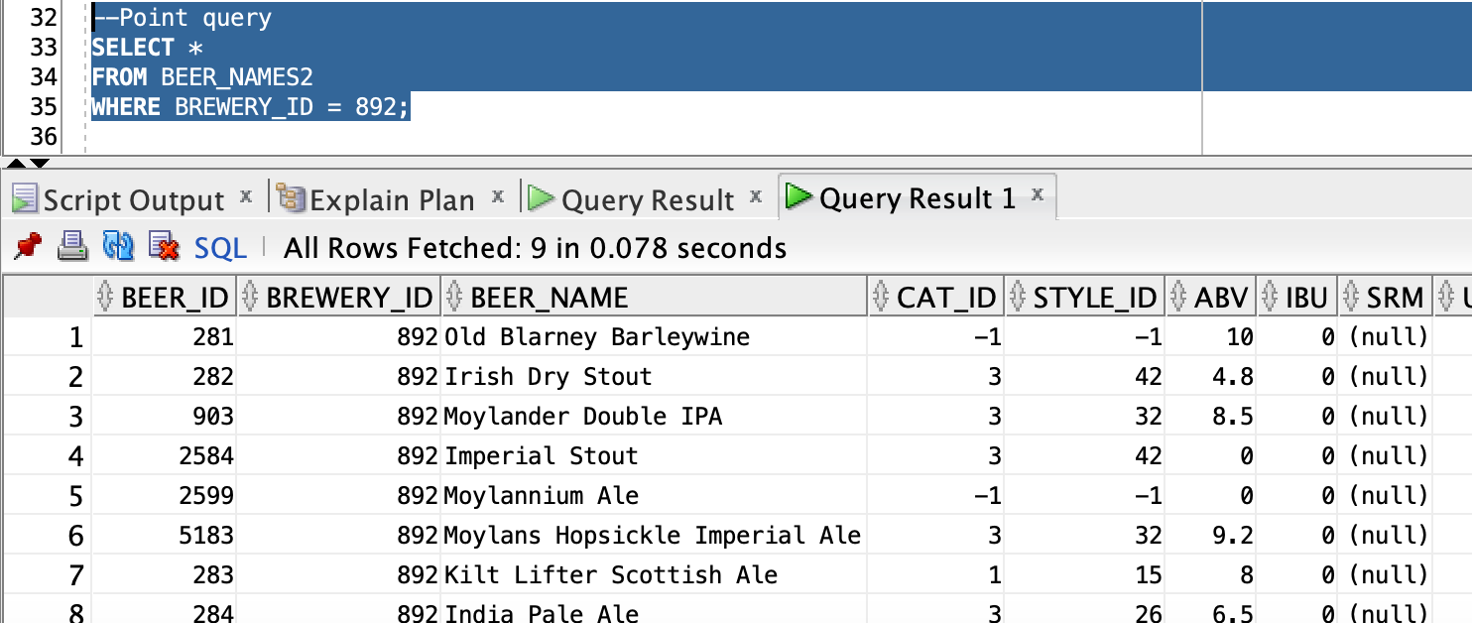

1. **Range Query**

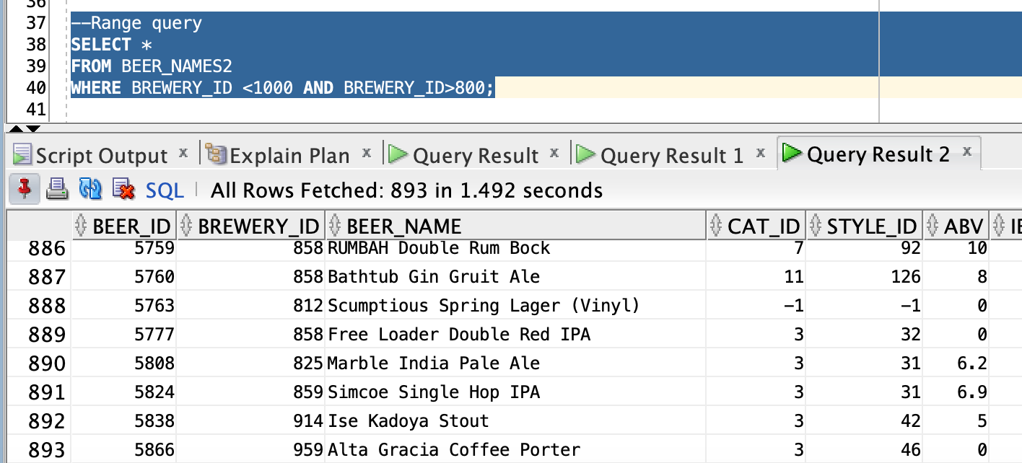

1. **Scan Query**

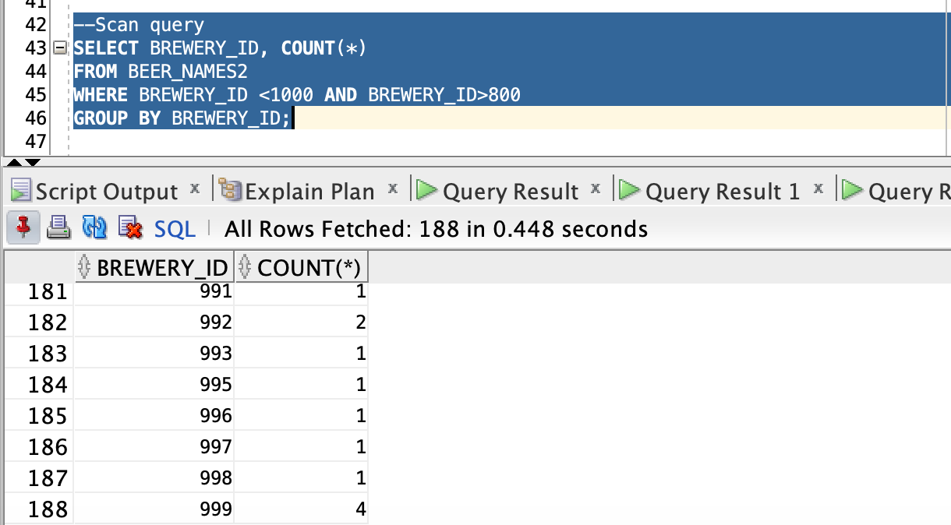

**Based on our experiments, we find that adding an index marginally improved results for point queries, reducing the time for retrieval by 0.009s in this case. However, adding an index did not improve performance for the range and scan queries.**

**This was an unexpected result which we investigated further and found that indexing often does not improve performance for range and scan queries as it forces the DB Engine to go through the index and then look up the data. In such cases a sequential read may be more optimized than an indexed read.**

## **Idea 5: Function-Based Indexes**

1. Before Function Based Indexing

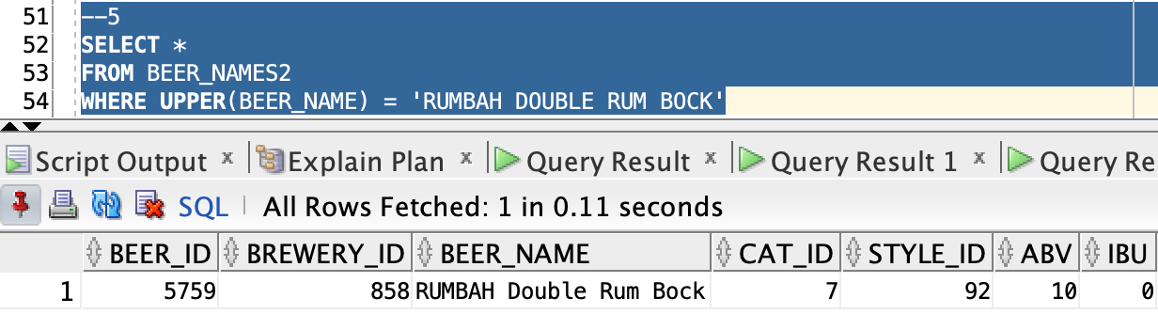

1. Creating Function Based index for BEERS_NAME

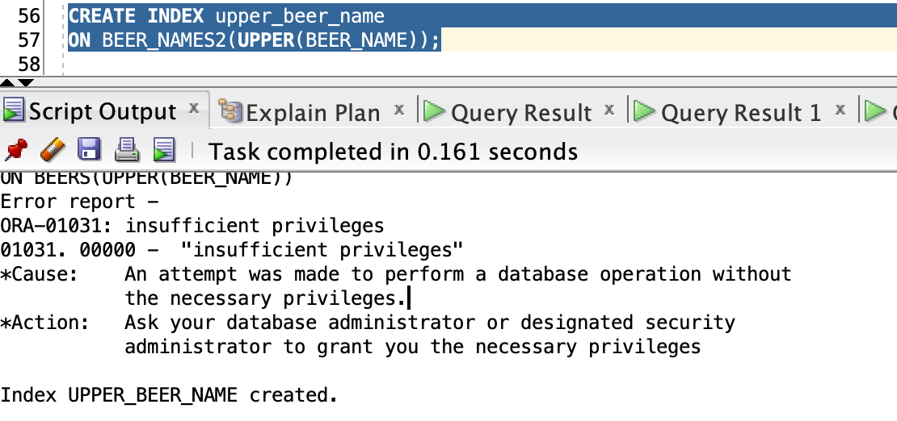

1. After Function Based Indexing

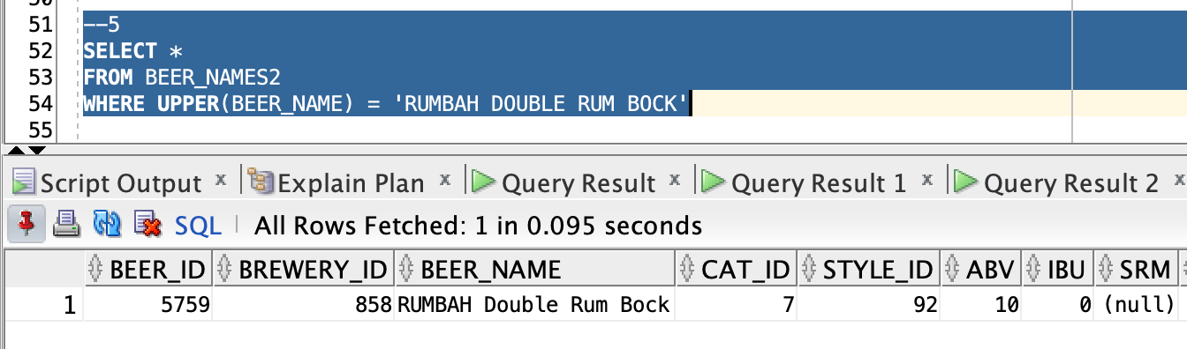

**Creating a simple function based index on BEER_NAME produced a significant performance improvement from 0.161s to 0.095s a difference of ~40%**

**Idea 6: Database Programming**

You might also consider doing a bit of database programming based on the previous special topic.  For instance, you could write a stored procedure to generate data, such as fan ratings of movies (or craft beers).  You could also build utility procedures or functions for manipulating the data or computing derived information like a composite movie rating.

1. Stored Procedure for inserting records into the beer_names1 table.

Here we are trying to insert a record into the beer_names1 table. Running this stored procedure while providing values as in below image for the parameters in the parenthesis above inserts records into the beer_names1 table as verified below.

1. Stored Procedure for retrieving the number of beers having a specific ABV value.

Here we have a stored procedure which has one IN parameter and one OUT parameter. The IN parameter takes the value of the ABV whose number of beers we would like to know and the OUT NUM_BEERS_PARAM outputs the number of beers available with the given ABV.

Below screenshots show how to provide the input parameter value and how to verify the output.

We can verify the answer by running a simple SELECT query.

